**Auto Scaling Text Box**

The Auto Scaling Text Box script is to be placed on a text box object.

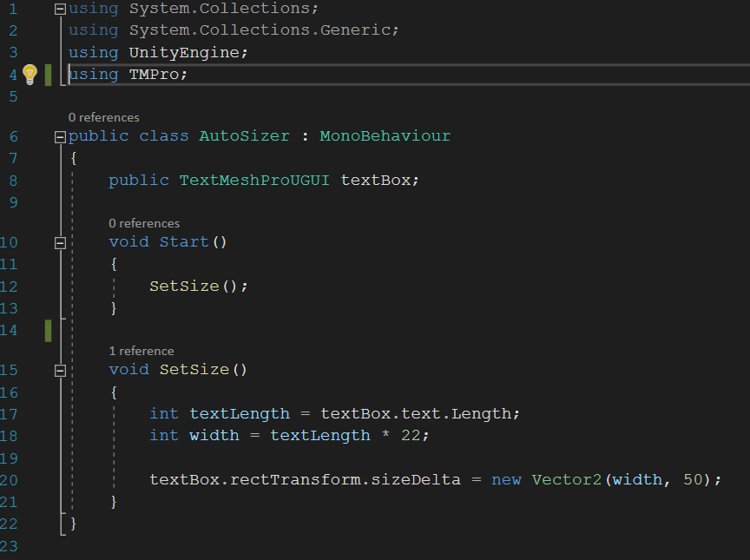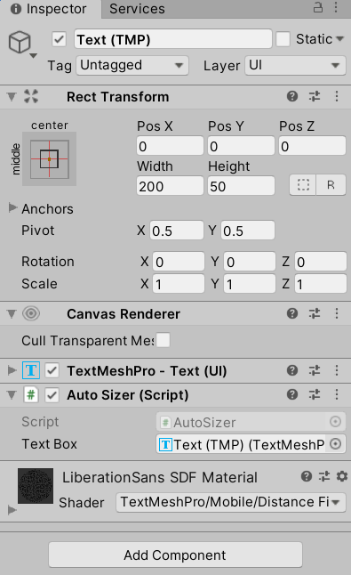

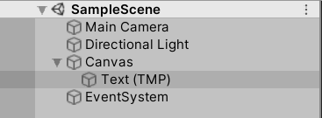

The script works by scaling the length of characters in the text box’s text variable by 22. The integer result of the character text multiplied by 22 is then set as the width of the text box element in the rect transform.